**CLOUD APPLICATION PROGRAMMING AND THE ANEKA PLATFORM**

Aneka is an Application Platform-as-a-Service (Aneka PaaS) for Cloud Computing. It acts as a framework for building customized applications and deploying them on either public or private Clouds. One of the key features of Aneka is its support for provisioning resources on different public Cloud providers such as Amazon EC2, Windows Azure and GoGrid.

* Aneka is a software platform for developing cloud computing applications.
* In Aneka, cloud applications are executed.
* Aneka is a pure PaaS solution for cloud computing.
* Aneka is a cloud middleware product.
* Manya can be deployed over a network of computers, a multicore server, a data center, a virtual cloud infrastructure, or a combination thereof.

**ANATOMY OF ANEKA CONTAINER**

Aneka is a platform and a framework for developing distributed applications on the Cloud.

It harnesses the spare CPU cycles of a heterogeneous network of desktop PCs and servers or datacenters on demand

Multiple containers can be classified into three major categories:

* Textile services
* Foundation Services
* Application Services

**1.Textile Services:**

Fabric Services defines the lowest level of the software stack that represents multiple containers. They provide access to resource-provisioning subsystems and monitoring features implemented in many.

**2. Foundation Services:**

Fabric Services are the core services of Manya Cloud and define the infrastructure management features of the system. Foundation services are concerned with the logical management of a distributed system built on top of the infrastructure and provide ancillary services for delivering applications.

**3. Application Services:**

Application services manage the execution of applications and constitute a layer that varies according to the specific programming model used to develop distributed applications on top of Aneka.

**BUILDING ANEKA CLOUDS**

Aneka is primarily a platform for developing distributed applications for clouds.

As a software plat- form it requires infrastructure on which to be deployed; this infrastructure needs to be managed.

Infrastructure management tools are specifically designed for this task, and building clouds is one of the primary tasks of administrators.

Aneka supports various deployment models for public, private, and hybrid clouds.

Aneka clouds can be realized in two models:

1. Infrastructure organization
2. Logical organization

**INFRASTRUCTURE ORGANIZATION:**

From an infrastructure point of view, the management of physical or virtual nodes is performed uniformly as long as it is possible to have an Internet connection and remote administrative access to the node

.A different scenario is constituted by the dynamic provisioning of virtual instances; these are generally created by pre-packaged images already containing an installation of Aneka, which only need to be configured to join a specific Aneka Cloud.

It is also possible to simply install the container or install the Aneka daemon, and the selection of the proper solution mostly depends on the lifetime of virtual resources.

**LOGICAL ORGANIZATION:**

the logical organization of aneka can be very diverse, since it strongly depends on the figuration selected for each of the containers instances belonging to the cloud. The most common scenario is to use a master-worker configuration with separate nodes for storage.

The master node features all the services that are most likely to be present in one single copy and that provide the intelligence of the aneka cloud. What specifically characterizers a node as a master node is the presence of the index service or membership catalogue configured in master mode: all the other services, except for those that are mandatory, might be present or located in the other nodes. A common configuration of the master node is as follows:

* Index service(master copy)
* Heartbeat service
* Logging service
* Reservation service
* Resource provisioning service
* Accounting service
* Reporting and monitoring service

**CLOUD DEPLOYMENT MODELS**

Cloud Deployment Model functions as a virtual computing environment with a deployment architecture that varies depending on the amount of data you want to store and who has access to the infrastructure.

There are four types of deployment models available in the cloud, namely,

1. Private
2. Public
3. Hybrid.

**PUBLIC CLOUD**

As its names suggest, the public cloud is available to the general public, and resources are shared between all users. They are available to anyone, from anywhere, using the Internet.

This computing model is hosted at the vendor’s data centre. The public cloud model makes the resources, such as storage and applications, available to the public over the WWW. It serves all the requests; therefore, resources are almost infinite model is one of the most popular types of cloud.

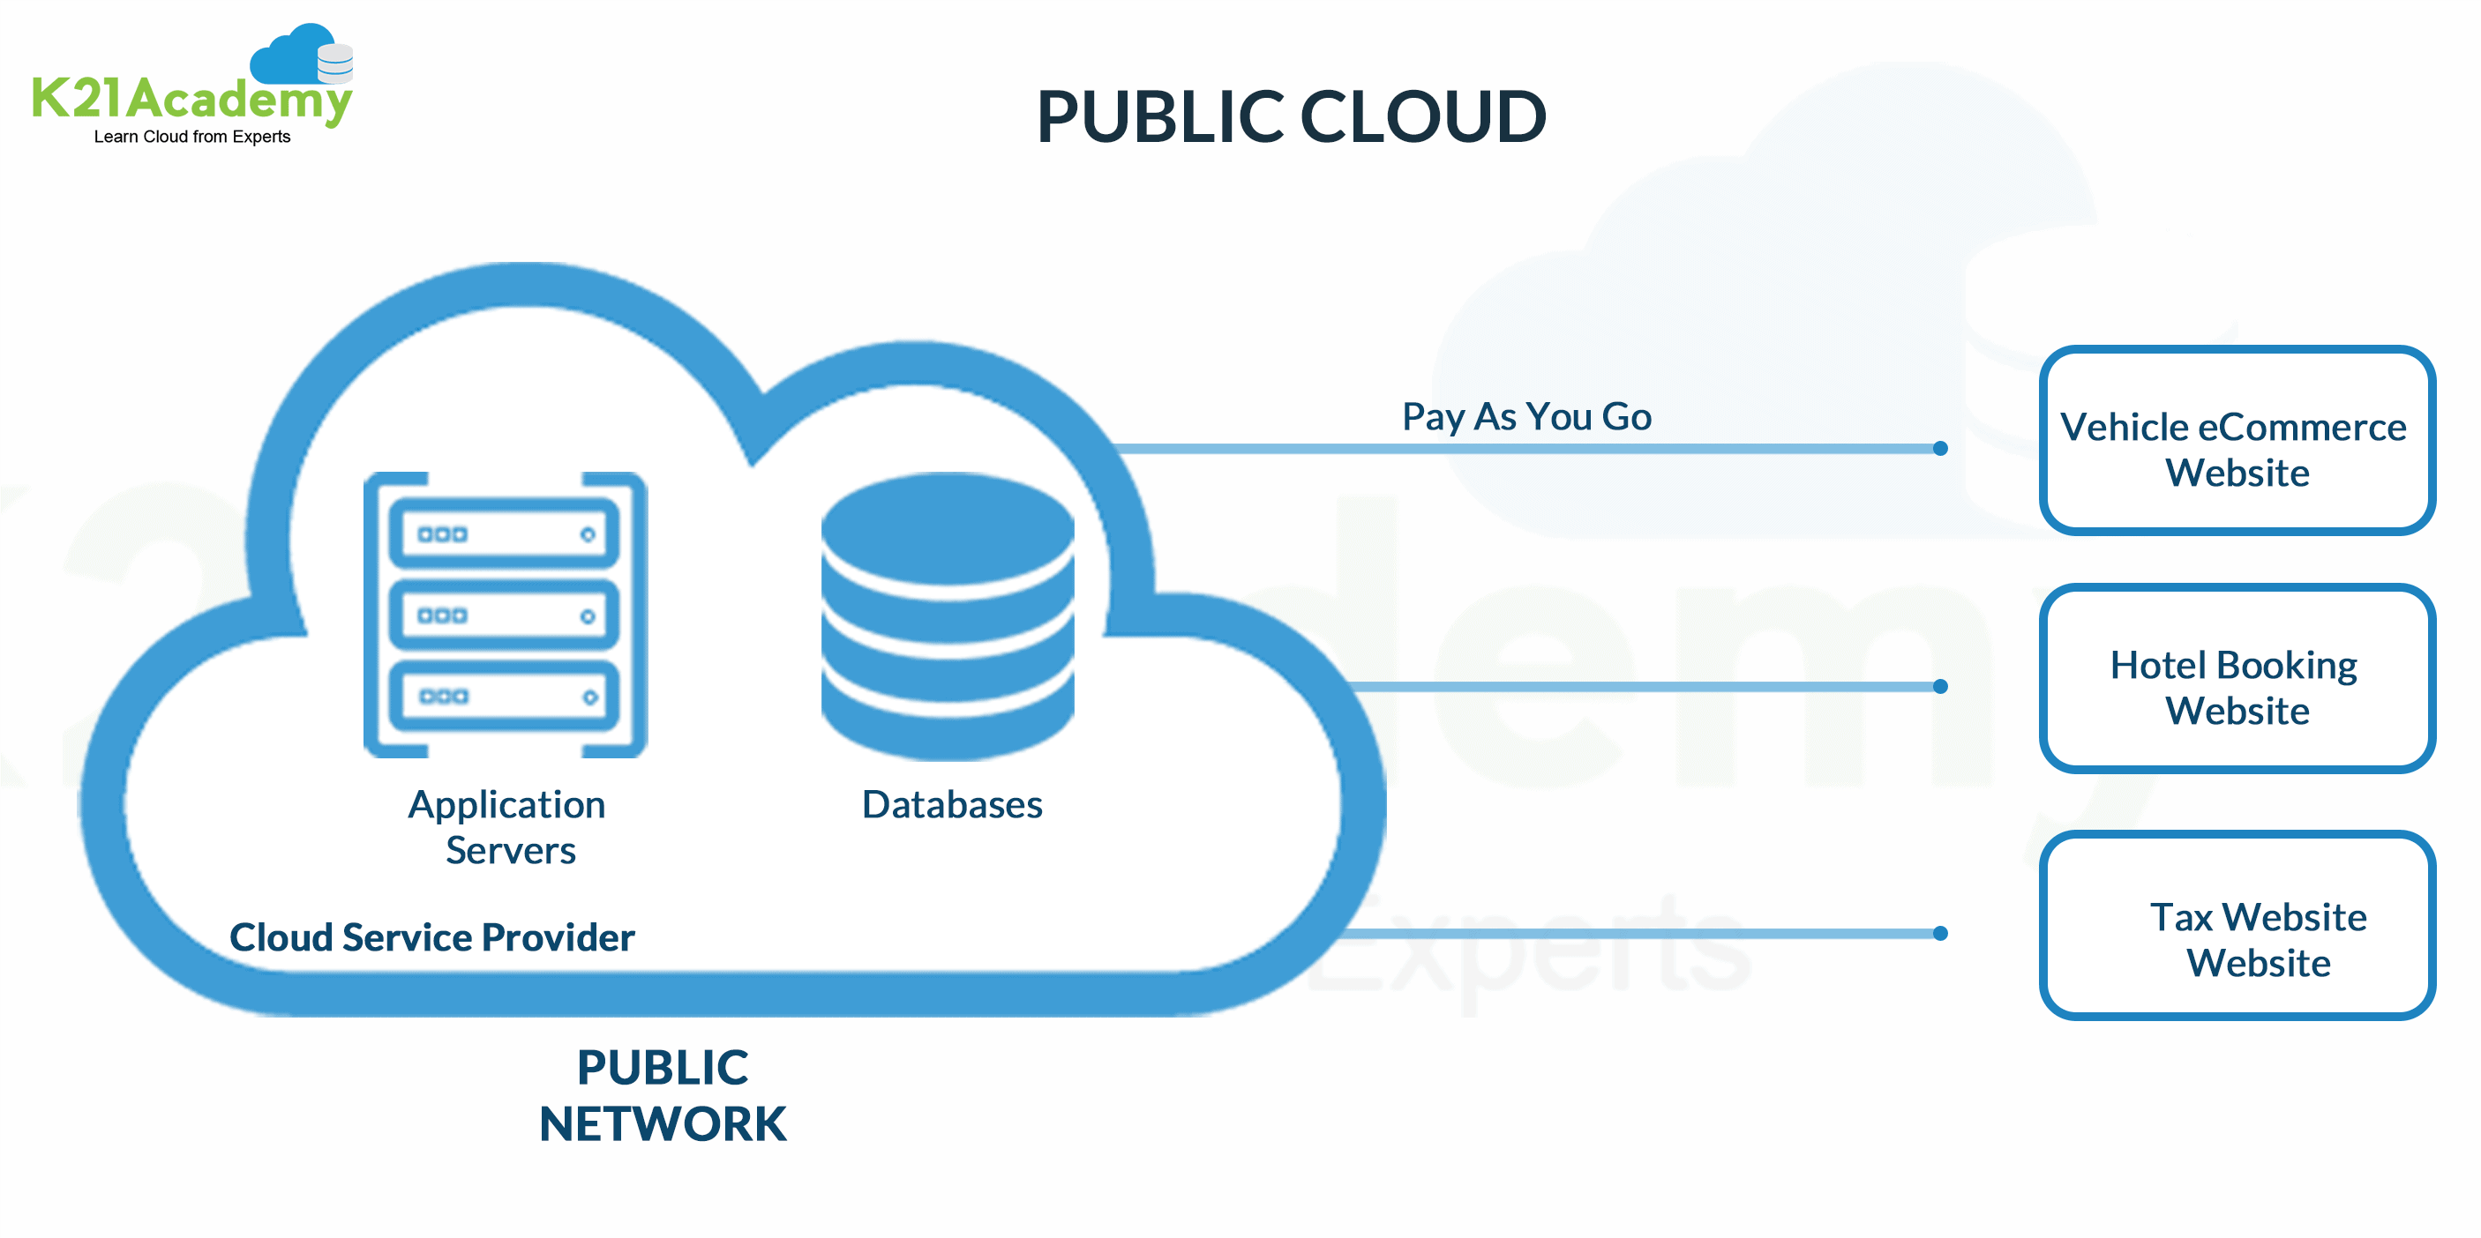

Examples of top Public Cloud Deployment model Providers:

* Amazon EC2
* Google App Engine
* Microsoft Azure
* IBM Cloud

**Characteristics of Public Cloud**

Here are the essential characteristics of the Public Cloud:

* Uniformly designed Infrastructure
* Works on the Pay-as-you-go basis
* Economies of scale
* SLA guarantees that all users have a fair share with no priority
* It is a multitenancy architecture, so data is highly likely to be leaked

**Advantages**

• There is no need of establishing infrastructure for setting up a cloud.

• There is no need for maintaining the cloud.

• They are comparatively less costly than other cloud models.

• Strict SLAs are followed.

• There is no limit for the number of users.

• The public cloud is highly scalable.

**Disadvantages**

• Security is an issue.

• Privacy and organizational autonomy are not possible.

**PRIVATE CLOUD MODEL**

The private cloud deployment model is a dedicated environment for one user or customer. You don’t share the hardware with any other users, as all the hardware is yours.

It is a one-to-one environment for single use, so there is no need to share your hardware with anyone else. The main difference between private and public cloud deployment models is how you handle the hardware. It is also referred to as “internal cloud,” which refers to the ability to access systems and services within an organization orborder.

**Characteristics of Private Cloud**

Here are the essential characteristics of the Private Cloud:

* It has a non-uniformly designed infrastructure.
* Very low risk of data leaks.
* Provides End-to-End Control.
* Weak SLA, but you can apply custom policies.
* Internal Infrastructure to manage resources easily.

**Advantages**

• The cloud is small in size and is easy to maintain.

• It provides a high level of security and privacy to the user.

• It is controlled by the organization.

**Disadvantages**

• For the private cloud, budget is a constraint.

* The private clouds have loose SLAs.

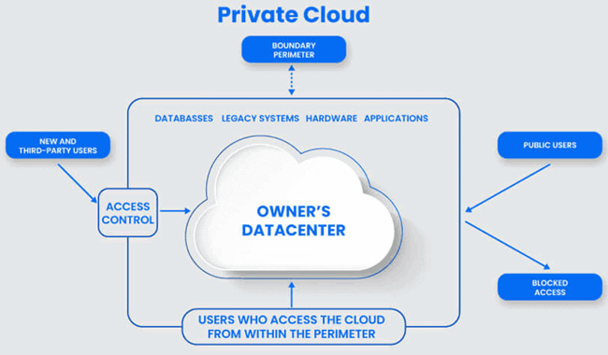

**HYBRID CLOUD MODEL**

A hybrid cloud deployment model combines public and private clouds. Creating a hybrid cloud computing model means that a company uses the public cloud but owns on-premises systems and provides a connection between the two. They work as one system, which is a beneficial model for a smooth transition into the public cloud over an extended period.

Some companies cannot operate solely in the public cloud because of security concerns or data protection requirements. So, they may select the hybrid cloud to combine the requirements with the benefits of a public cloud. It enables on-premises applications with sensitive data to run alongside public cloud applications.

**Characteristics of Private Cloud**

Here are the Characteristics of the Private Cloud:

* Provides betters security and privacy
* Offers improved scalability
* Cost-effective Cloud Deployment Model
* Simplifies data and application portability

[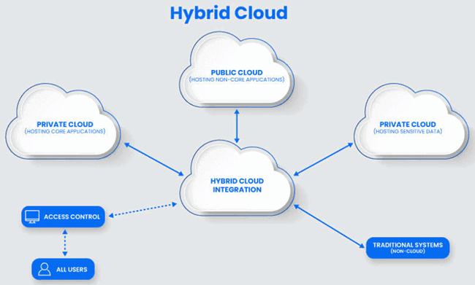](https://www.guru99.com/images/3/cloud-deployment-model-4.png)

**Advantages**

• It gives the power of both the private and public clouds.

• It is highly scalable.

• It provides better security than the public cloud.

**Disadvantages**

• The security features are not as good as the public cloud.

• Managing a hybrid cloud is complex.

• It has stringent SLAs

**ANEKA -SOFTWARE DEVELOPMENT KIT (SDK)**  
  
This is a collection of tools, libraries, and documentation. It enables developers to build custom applications that can run on the Aneka platform. It includes APIs for accessing the Aneka services and tools for developing and testing applications.

Aneka provides APIs for developing applications on top of existing programming models, implementing new programming models, and developing new services to integrate into the Aneka Cloud.

The development of applications mostly focuses on the use of existing features and leveraging the services of the middleware, while the implementation of new programming models or new services enriches the features of Aneka.

The SDK provides support for both programming models and services by means of the Application Model and the Service Model.

The former covers the development of applications and new programming models; the latter defines the general infrastructure for service development.

The SDK provides support for both programming model and services by

* Application models
* Service models

**Application Model**

Aneka provides support for distributed execution in the Cloud with the abstraction of programming models.A programming model identifies both the abstraction used by the developers and the runtime support for the execution of programs on top of Aneka.The Application Model represents the minimum set of APIs that is common to all the programming models for representing and programming distributed applications on top of Aneka.This model is further specialized according to the needs and the particular features of each of the programming models.

**Service model**

The Aneka Service Model defines the basic requirements to implement a service that can be hosted

in an Aneka Cloud. The container defines the runtime environment in which services are hosted.

Each service that is hosted in the container must be compliant with the IService interface, whichexposes the following methods and properties:

• Name and status

• Control operations such as Start,Stop,Pause, and Continue methods

• Message handling by means of the HandleMessage method

Fig describes the reference life cycle of each service instance in the Aneka container. The shaded balloons indicate transient states; the white balloons indicate steady states. A service instance can initially be in the **Unknown or Initialized state**, a condition that refers to the creation of the service instance by invoking its constructor during the configuration of the container. Once the container is started, it will iteratively call the **Start** method on each service method.

As a result the service instance is expected to be in a Starting state until the start up process is completed, after which it will exhibit the state. This is the condition in which the service will last as long as the container is active and running. This is the only state in which the service is able to process messages. If an exception occurs while starting the service, it is expected that the service will fall back to the Unknown state, thus signalling an error. When a service is running it is possible to pause its activity by calling the method and resume it by calling Continue.

As described in the figure, the service moves first into the Pausing state, thus reaching the **Paused** state. From this state, it moves into the **Resuming** state while restoring its activity to return to the Running state. Not all the services need to support the pause/continue operations, and the current implementation of the framework does not feature any servicewith these capabilities.When the container shuts down, the Stop method is iteratively called on each service running,and services move first into the transient Stopping state to reach the final Stopped state, where allresources that were initially allocated have been released.

Note: here all unfilled circle: running, unknown, initialize, paused and stopped are steady states

The filled circle: starting, pausing , resuming and stopping are transient states.

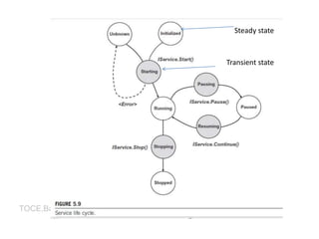

**MANAGEMENT TOOLS**

Aneka is a pure PaaS implementation and requires virtual or physical hardware to be deployed. Hence, infrastructure management, together with facilities for installing logical clouds on such infrastructure, is a fundamental feature of Aneka’s management layer.

1. Infrastructure management
2. Platform management
3. Application management

**Infrastructure management**

Aneka leverages virtual and physical hardware in order to deploy Aneka Clouds. Virtual hardwareis generally managed by means of the Resource Provisioning Service, which acquires resources ondemand according to the need of applications, while physical hardware is directly managed by theAdministrative Console by leveraging the Aneka management API of the PAL. The managementfeatures are mostly concerned with the provisioning of physical hardware and the remote installation of Aneka on the hardware.

**Platform management**

Infrastructure management provides the basic layer on top of which Aneka Clouds are deployed.

The creation of Clouds is orchestrated by deploying a collection of services on the physical infrastructure that allows the installation and the management of containers. A collection of connectedcontainers defines the platform on top of which applications are executed. The features availablefor platform management are mostly concerned with the logical organization and structure ofAneka Clouds.

It is possible to partition the available hardware into several Clouds variably configured for different purposes. Services implement the core features of Aneka Clouds and the management layer exposes operations for some of them, such as Cloud monitoring, resource provisioningand reservation, user management, and application profiling

**Application management**

Applications identify the user contribution to the Cloud. The management APIs provide administrators with monitoring and profiling features that help them track the usage of resources and relatethem to users and applications. This is an important feature in a cloud computing scenario in whichusers are billed for their resource usage.

Aneka exposes capabilities for giving summary anddetailed information about application execution and resource utilization.

All these features are made accessible through the Aneka Cloud Management Studio, which

constitutes the main Administrative Console for the Cloud